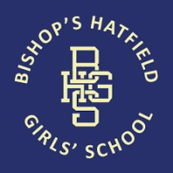

To order your Bishops Hatfield Girls School Leavers yearbook
simply control and click on the link below

www.boomedsales.com/bishops-hatfield

The yearbook costs £15.50 for an A4 hardback book full of school memories

All orders must be received by the 28th May 2023

Any queries please contact Mrs M Mansfield

by email
MMansfield@bishophatfield.herts.sch.uk

Please note that the hoodies and yearbooks will be delivered directly to the school who will notify you when they are ready for collection.
Please be aware that the hoodies and yearbooks will not be able to be ordered past the closing date.

