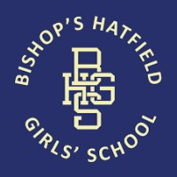

To order your Bishop’s Hatfield Girls’ School Leavers Hoodie simply press control and click on the link below

https://www.boomedsales.com/bishops-hatfield-girls-school

All orders must be received by the 11th June 2021
£22.00 for a plain coloured hoodie and £26.00 for a 2 Tone Hoodie both include the school logo embroidered on the front left and back print design. Nicknames can be added at an additional cost of £4.00.

Any queries please contact Mrs Dayton
by email mdayton@bishophatfield.herts.sch.uk

