22nd March 2021

Dear Year 7 Parents/Carers,

Due to the current situation we are unable to hold the Year 7 Parents information evening as planned.

We have created a presentation covering key information regarding Year 7 reporting linked below. It is important that all parents are aware of the points raised in this presentation in advance of reports being published at the end of this week, we hope you will find this helpful.

Please click on the link below to see this presentation.

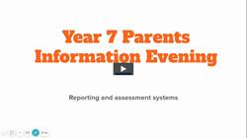

Yours sincerely,

Mr H Pandya
Assistant Headteacher

