World Challenge Vietnam Trip- Parents Information Evening- Tomorrow 6:30pm

Hi all,

Thanks to everyone who has signed up to attend the virtual parents information evening tomorrow to hear more about the upcoming trip to Vietnam in 2022. If any of you have lost the link or not managed to go online to have a look then here is the link to the landing page again: https://ourworldchallenge.com/qapa32um/

In addition here is the direct link to join the zoom tomorrow, just click on the link at 6:30pm and you will join the room- Vietnam 2022!

I really look forward to seeing you all tomorrow.

Many thanks,

Emma

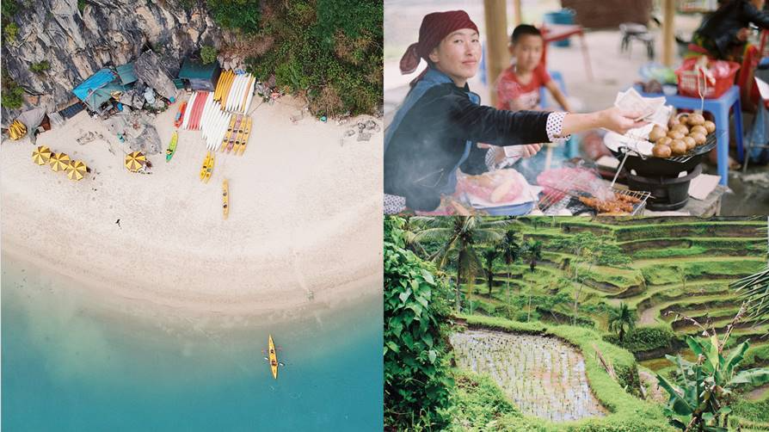

EMMA BRUGGENWIRTH
School Account Manager
weareworldchallenge.com

