Revision Guide

Top Five Revision Tips
  - Start your revision in good time and plan a revision timetable.
  - Find a quiet place to revise – your bedroom, school, the local library –
and refuse to be interrupted or distracted.
  - Short spurts of revision (25-30 minutes) are most effective. Your concentration lapses after about an hour and you need to take a short break (5-10 minutes).
  - In the evenings after school, plan two (or three) subjects only. Leave time for relaxation.
  - Plan to revise specific topics or aspects of a subject – for example, not just ‘German’ but ‘German – weather’

Revising at home: Know how you learn best
Everybody has a way of learning that suits them well. What works best for you?
Try some of these to see what works for you:
- Music in the background sometimes helps, but don’t try to revise with the TV or radio on.
- Read through a topic and make brief notes on cards which can be used for further revision later.
- Instead of writing notes in words, draw a picture.
- Redraw diagrams and check how well they match the original.
- Use flow charts to sequence events or activities. Use linking words between boxes to illustrate the nature of the sequence.
- Use colours to highlight key words in your notes.
- Work with a partner to help and test each other on, for example, performing calculations, recalling linked facts or dates, drawing conclusions from evidence, explaining the meaning of key words (and spelling them correctly, also in French and Spanish), etc.

Year 9 Examinations 2018
 | Periods 1 & 2 | Periods 3 & 4 | Periods 5 & 6
Wednesday 24 Jan | Normal lessons | Science | Computing
Thursday 25 Jan | History | German / Spanish | English Literature
Friday 26 Jan | Mathematics 1 | English Language | Religious Studies
Monday 29 Jan | Mathematics 2 | Geography | French

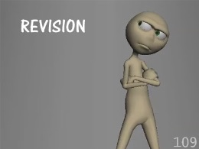
Example of a Daily Revision Diary

Day/date | Subjects | Time | Activities
Monday 22 Jan | Geography  German  English | 4.00 – 4.25  4.35 – 4.55  5.15 – 6.15  6.30 – 8.00  8.00 – 8.20 | ‘Geography – rivers’  ‘German – weather’ (linguascope.com)  Dance club  Dinner / Help in the kitchen  Practise spelling keywords

Check that:
- You have time to revise everything and to go over topics more than once.
- You are not taking on too much at any one time.
- Just before each exam you have enough time to go over that subject.
Try to stick to your plan, but remember you can adjust it as you go along as long as adjusting does not mean skipping bits.
Hang your plan on your bedroom wall or somewhere you can easily see it.
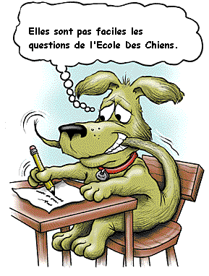
J’aurais dû mieux reviser.

Day/date | Subjects | Time | Activities
Monday
8 Jan
Tuesday
9 Jan

Wednesday
10 Jan

Thursday
11 Jan

Friday
12 Jan

Saturday
13 Jan

Sunday
14 Jan

Monday
15 Jan
Tuesday
16 Jan

Wednesday
17 Jan

Thursday
18 Jan

Friday
19 Jan

Saturday
20 Jan
REMEMBER! 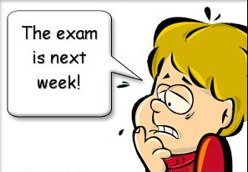

 | Periods 1 & 2 | Periods 3 & 4 | Periods 5 & 6
Wednesday 24 Jan | Normal lessons | Science | Computing
Thursday 25 Jan | History | German / Spanish | English Literature
Friday 26 Jan | Mathematics 1 | English Language | Religious Studies
Monday 29 Jan | Mathematics 2 | Geography | French

Day/date | Subjects | Time | Activities
Sunday
21 Jan
Monday
22 Jan

Tuesday
23 Jan

Wednesday
24 Jan

Thursday
25 Jan

Friday
26 Jan

Saturday
27 Jan

Sunday
28 Jan

